Name : Gowtham S
Roll no : 24BAD028
24ADC001 — BUSINESS INTELLIGENCE
LAB ASSIGNMENT

LAB 1 — POWER BI

1.PedalShare: Building an OLAP Cube for a City Bike-Share Network.

Screenshots :

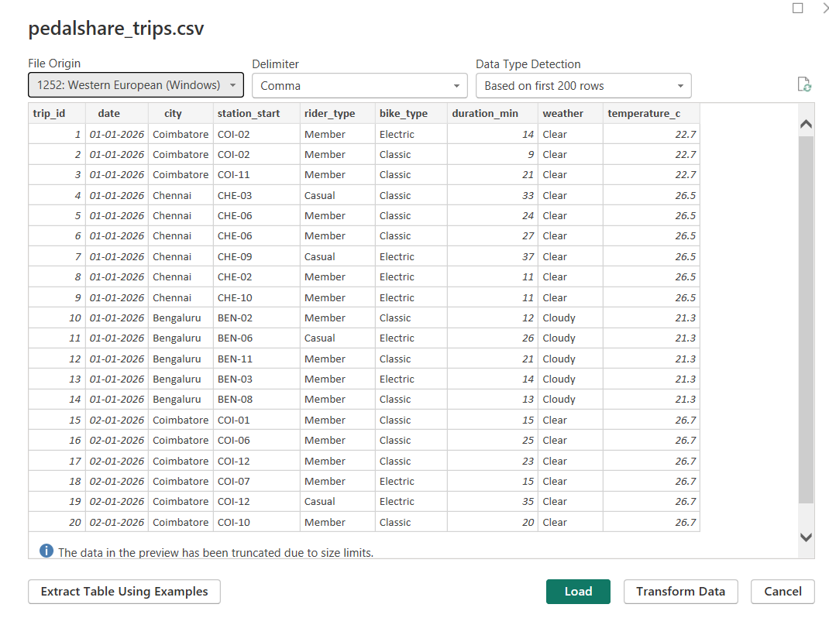

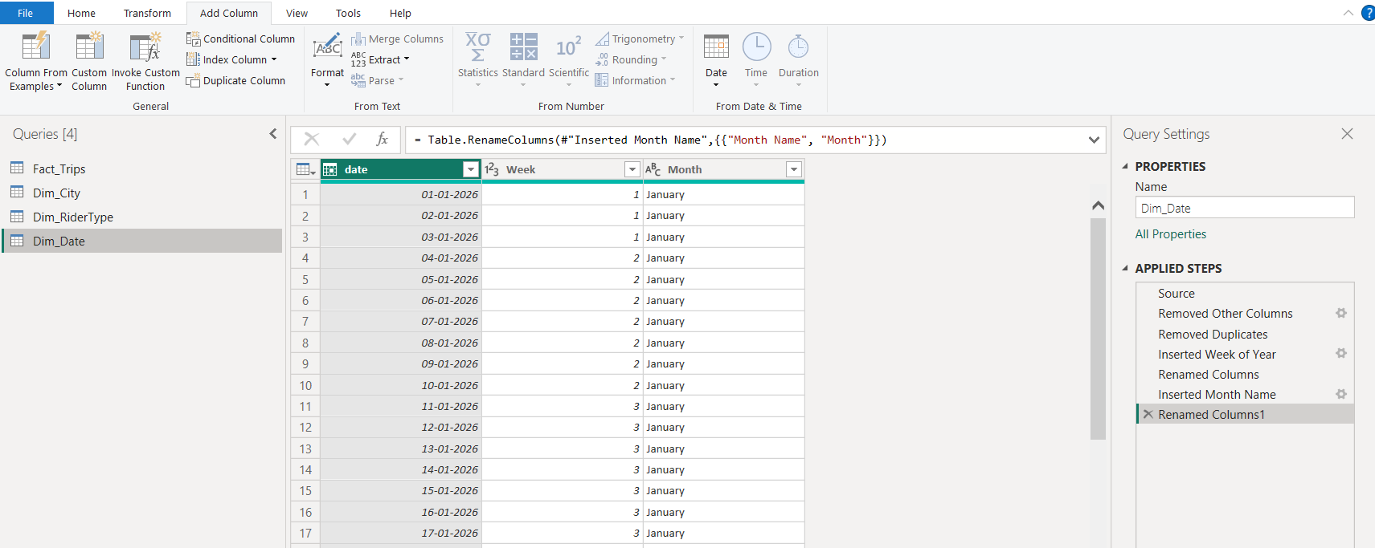
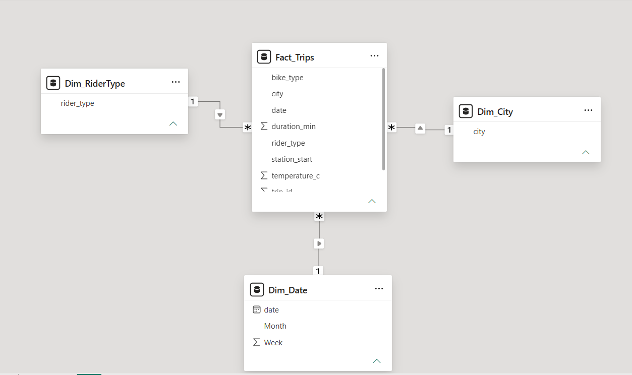
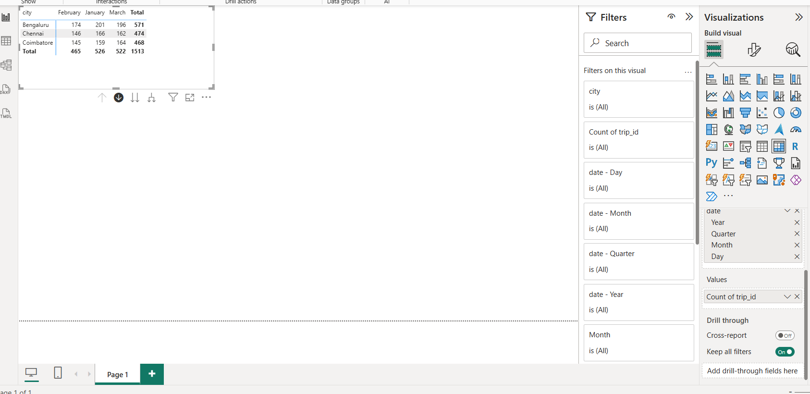
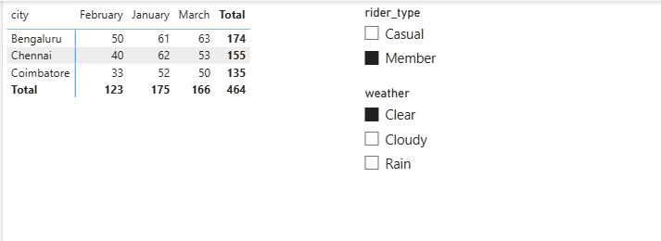

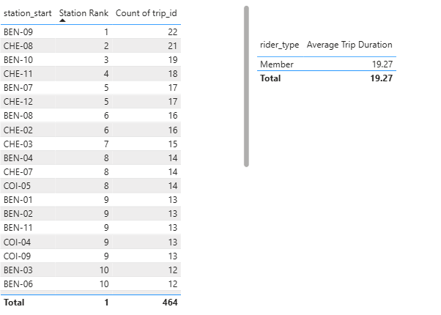
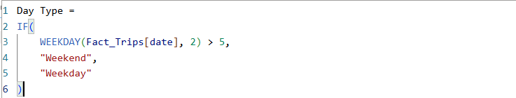
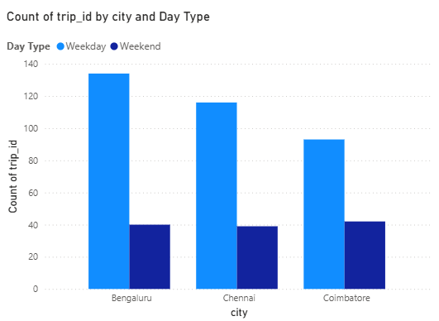
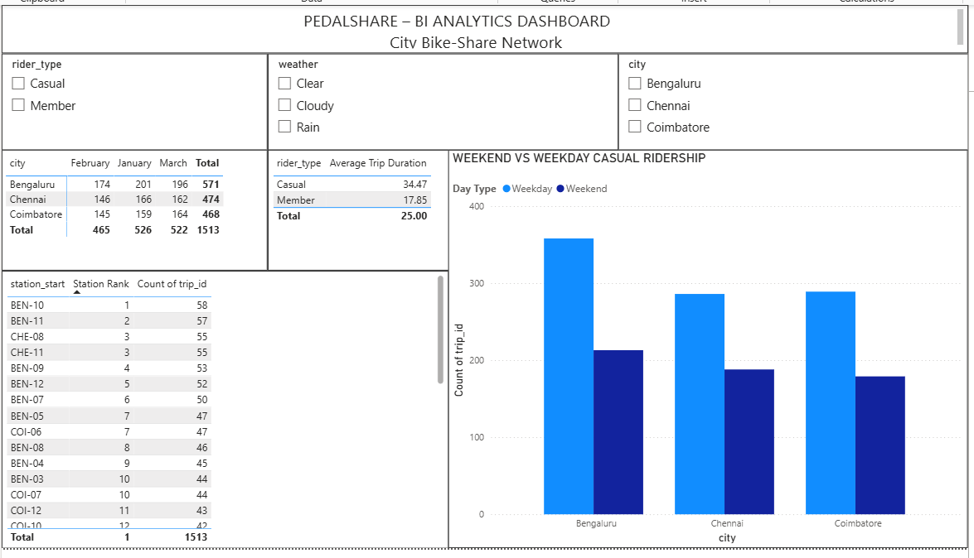
Write-up :
PedalShare: Building an OLAP Cube for a City Bike-Share Network
Aim :
To build a star-schema analytical model in Power BI for the PedalShare bike-share network and use OLAP operations such as roll-up, drill-down, slice, and dice to analyze trip activity across cities, rider types, weather conditions, and time periods.
Implementation :
The pedalshare_trips.csv dataset was imported into Power BI and transformed using Power Query. The data was divided into the main Fact_Trips table and three dimension tables: Dim_City, Dim_RiderType, and Dim_Date. Relationships were created in Model view using a star-schema structure, with the dimension tables connected to the central fact table. The Matrix visual was created with City on rows and Month, Week, and Date on columns to support monthly, weekly, and daily drill-down analysis. Slicers were added for rider type and weather to demonstrate slicing and dicing. Two DAX measures were created: Station Rank using RANKX() to rank stations by total trips and Average Trip Duration to calculate the average trip duration.
Weekend Ridership Investigation :
The weekend casual-ridership pattern was investigated using a comparison of Weekend versus Weekday casual trips across Bengaluru, Chennai, and Coimbatore. The dataset contains 1,513 trips. The analysis showed that casual ridership was higher on weekends in all three cities:
City | Weekday Casual Trips | Weekend Casual Trips
Bengaluru | 111 | 142
Chennai | 85 | 124
Coimbatore | 76 | 113
Therefore, the weekend casual-ridership increase is not driven by only one city. The pattern appears consistently across Bengaluru, Chennai, and Coimbatore. This indicates that the weekend effect is a broader ridership pattern across the PedalShare network rather than a city-specific anomaly.

Conclusion :
The Power BI model successfully demonstrates star-schema design, OLAP roll-up and drill-down, slicing and dicing, and DAX-based analysis. The investigation also confirms that casual ridership increases on weekends across all three cities.

LAB 2 — TABLEAU
2. CityCare Hospital: A Decision Support Dashboard for the Emergency Department
Screenshots :
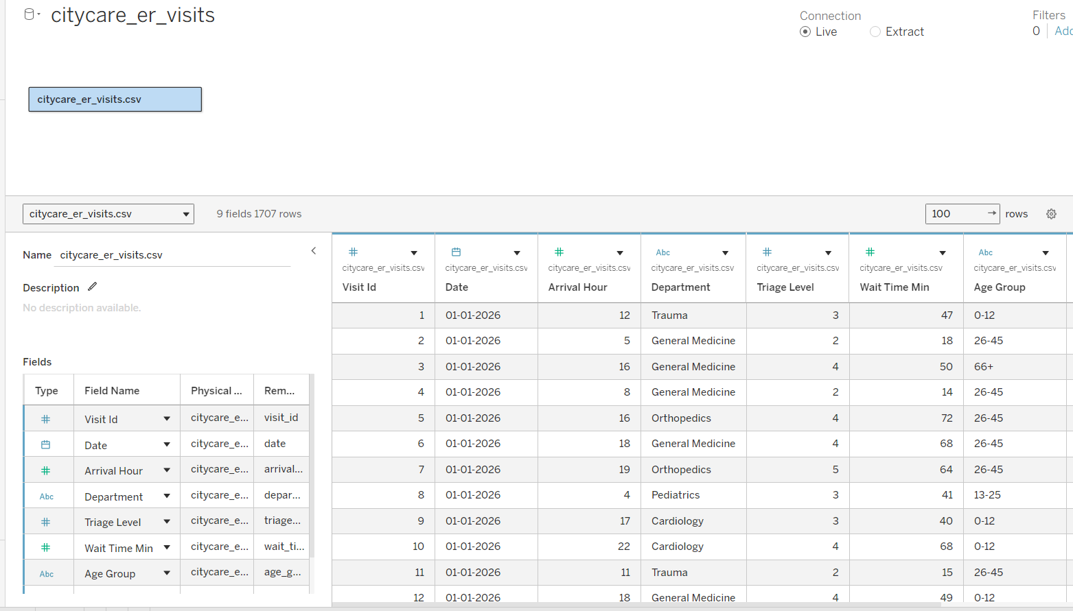
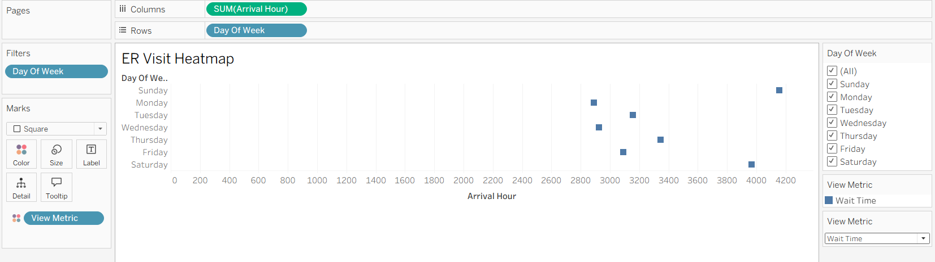
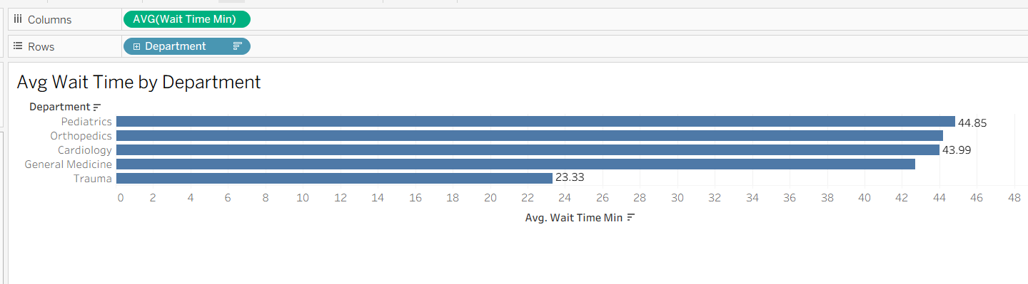
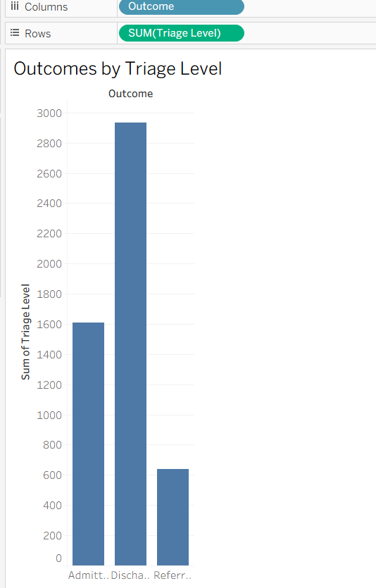
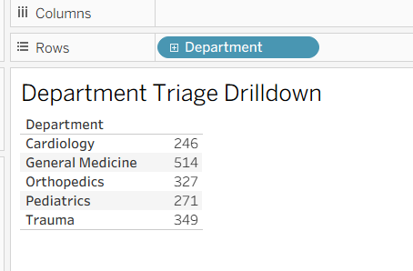
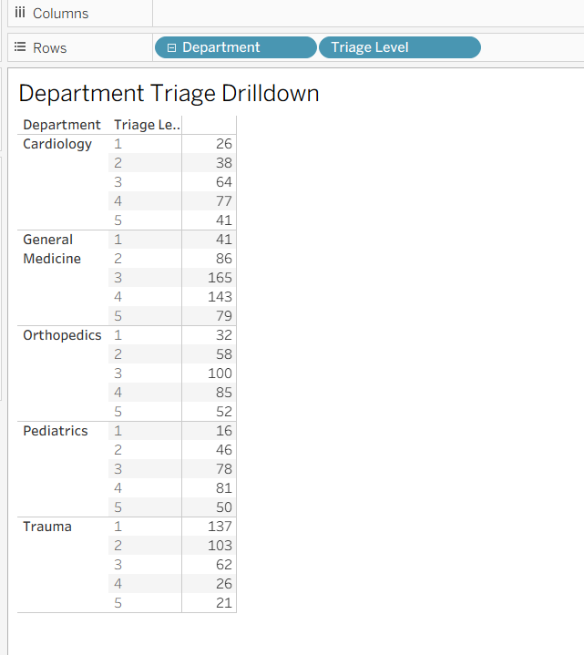
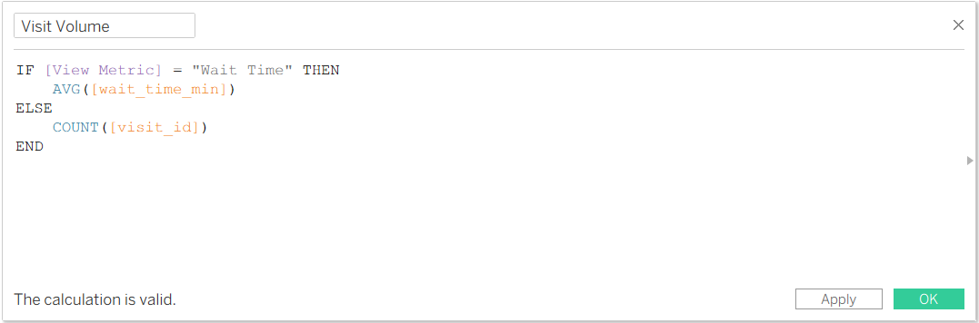

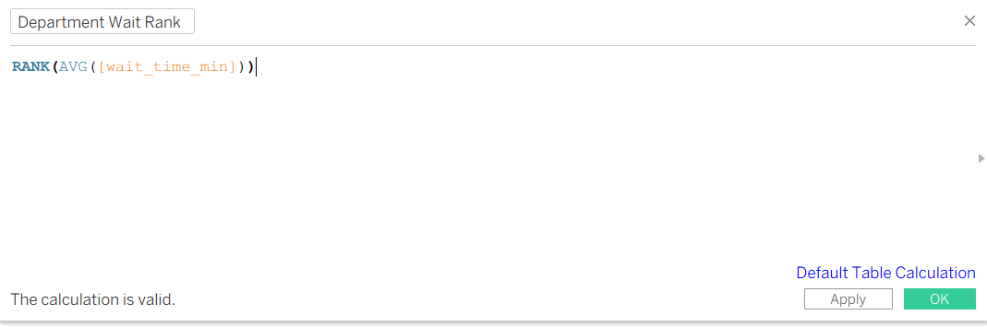
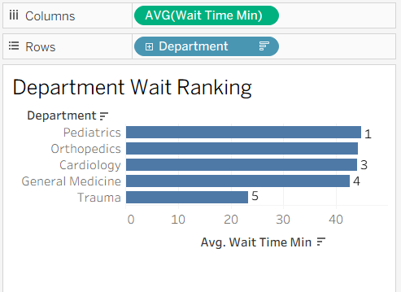
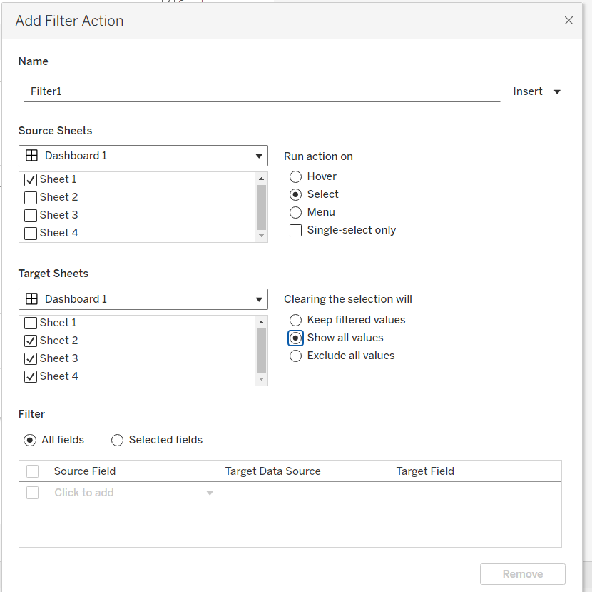
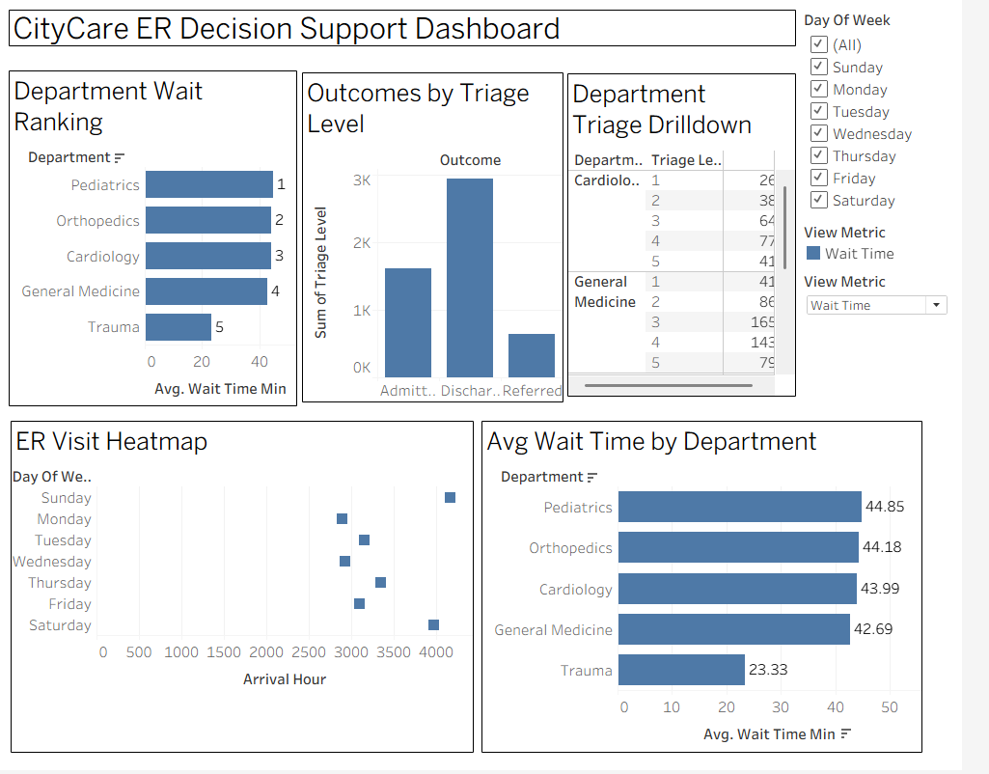

Writeup :
CityCare Hospital: A Decision Support Dashboard for the Emergency Department
Aim :
To build a Tableau decision-support dashboard for CityCare Hospital's Emergency Department and use data-driven analysis to identify high-demand periods and support staffing decisions.
Implementation :
The citycare_er_visits.csv dataset was connected to Tableau. Three main worksheets were created: a heatmap showing visit volume by day of week and arrival hour, a bar chart showing average wait time by department, and a breakdown of outcomes by triage level. A Department → Triage Level hierarchy was created to demonstrate drill-down and collapse operations. A day-of-week filter and a parameter were added to switch between average wait time and visit volume. A calculated field using a table calculation was also created to rank departments by average wait time. The worksheets were combined into a single dashboard with an action filter to connect the views.
200-Word Recommendation :
The decision of when to add emergency department staff is best classified as a semi-structured decision. The dashboard provides objective evidence about patient demand and waiting times across different days, hours, departments, and triage levels. These measurable patterns make part of the staffing decision structured because managers can identify periods when workload and waiting times are consistently higher. In particular, the analysis helps investigate the weekend-night period from 6 PM to 11 PM, when visit volume and waiting-time pressure are higher.
However, staffing decisions cannot be determined entirely by historical dashboard results. Hospital managers must also consider current patient severity, staff availability, planned leave, available beds, unexpected emergencies, and other operational conditions. These factors require experience and professional judgment.
The Decision Support System should therefore support managers by providing reliable evidence, highlighting high-demand periods, comparing departmental waiting times, and making important patterns easier to identify. The DSS can reduce manual analysis and improve consistency, but it should not replace managerial judgment. The manager should interpret the dashboard in the context of the current hospital situation and make the final staffing decision.
Therefore, CityCare should use the DSS as an evidence-based decision-support tool, while retaining final responsibility for staffing decisions with the hospital manager.

LAB 3 — OPENAI (CHATGPT)
3. SupportDesk: Turning Trapped Tacit Knowledge Into a Rule-Based Troubleshooting Guide

Screenshots :

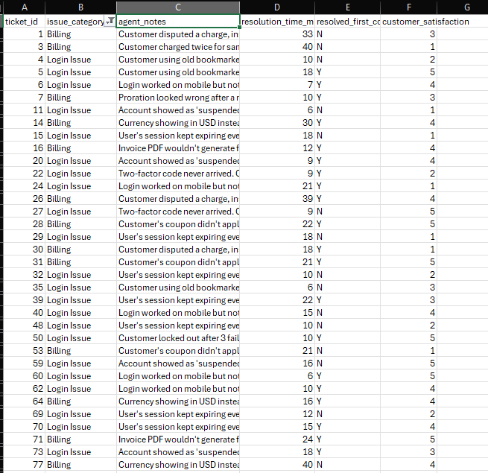

Step 1 — Common root causes
Root cause | Evidence from the notes
Old bookmarked login URL | Customers were using the old URL from before the domain migration.
Browser cache/cookie problem | Login worked on mobile but not desktop; clearing site-specific cookies fixed it.
Browser extension blocking authentication cookies | Sessions expired repeatedly because an extension blocked the auth cookie.
Two-factor authentication delivery delay | 2FA codes did not arrive because of delayed SMS carrier delivery.
Account lockout after failed login attempts | Customer was locked out after 3 failed attempts; password reset and lockout clearing resolved it.

Step 2 — Draft the IF–THEN Troubleshooting Rules

Rule 1 — Old Login URL
IF the customer cannot log in and is using an old bookmarked login URL from before the domain migration,
THEN direct the customer to the new login URL and ask them to update their bookmark.
Ticket evidence:
“Customer using old bookmarked login URL from before our domain migration.”

Rule 2 — Desktop Login / Cache Problem
IF login works on mobile but does not work on the desktop browser,
THEN ask the customer to clear the cookies for the company's domain specifically and retry the login.
Ticket evidence:
“Login worked on mobile but not desktop. Cache issue.”

Rule 3 — Session Expiring Repeatedly
IF the customer's session repeatedly expires after a short period,
THEN check whether a browser extension is blocking the authentication cookie and ask the customer to disable the conflicting extension.
Ticket evidence:
“User's session kept expiring every 2 minutes.”

Rule 4 — Two-Factor Code Not Received
IF the customer does not receive the two-factor authentication code,
THEN check the SMS delivery status; when carrier delivery is delayed, advise the customer to use an authenticator app instead.
Ticket evidence:
“Two-factor code never arrived.”

Rule 5 — Account Locked After Failed Attempts
IF the customer is locked out after three failed login attempts,
THEN reset the customer's password and clear the account lockout flag through the administrative panel.
Ticket evidence:
“Customer locked out after 3 failed attempts.”

Rule 6 — Cancellation Not Properly Confirmed
IF a customer disputes a charge because they believe they cancelled their subscription, AND the logs show that the cancellation request was submitted but was not confirmed in step 2,
THEN investigate the cancellation flow as a possible UX issue rather than assuming customer error.
Ticket evidence:
“Cancellation request was submitted but never confirmed in step 2 of the flow.”

Rule 7 — Duplicate Billing Charge
IF a customer was charged twice for the same invoice, AND the logs show a retry caused by a failed webhook,
THEN refund the duplicate charge and flag the webhook retry logic for engineering investigation.
Ticket evidence:
“Customer charged twice for same invoice due to a retry from a failed webhook.”

Rule 8 — Incorrect Currency
IF the customer's billing currency does not match the currency expected from their billing address,
THEN verify the account currency, correct it when appropriate, and record the issue for the localization team.
Ticket evidence:
“Currency showing in USD instead of INR despite India billing address.”

Rule 9 — Coupon Not Applying
IF a customer's coupon does not apply at checkout,
THEN check the coupon's expiry date before treating the issue as a system failure; if it has expired, explain the expiry and consider issuing a replacement.
Ticket evidence:
“Coupon had expired 1 day before the call.”

Rule 10 — Enterprise Invoice PDF
IF an enterprise customer cannot generate an invoice PDF, AND the invoice contains more than eight line items,
THEN treat the issue as a possible template bug and escalate it to engineering rather than treating it as a customer error.
Ticket evidence:
“Template bug only triggered when line items exceed 8 rows.”

Step 3 — Cross-Check the Rules with 5 Other Tickets

Cross-check table
Test Ticket / Situation | Applicable Rule | Would the rule work? | Result
Customer sees USD instead of INR | Rule 8 – Incorrect Currency | Yes | Currency can be checked and corrected
Customer's coupon does not apply | Rule 9 – Coupon Not Applying | Yes | Check expiry before treating it as a system error
Duplicate charge on same invoice | Rule 7 – Duplicate Billing Charge | Yes | Refund duplicate and flag webhook retry
Enterprise invoice PDF fails with >8 line items | Rule 10 – Enterprise Invoice PDF | Yes | Escalate as a possible template bug
Customer thinks proration is wrong after upgrade | No existing rule | No | Need a new rule

The first four cases are already covered by our rules. The proration case exposes a gap.
Refine the rule set
Add this rule:
Rule 11 — Proration Appears Incorrect
IF a customer reports that a mid-cycle upgrade produced an incorrect proration amount,
THEN walk through the proration calculation with the customer line by line before making an adjustment; if the calculation is correct, explain how the amount was derived.
Ticket evidence:
“Proration looked wrong after a mid-cycle upgrade... it was actually correct, just confusing to read.”
This is useful because the cross-check shows that not every billing complaint is caused by an actual billing error.
Cross-check conclusion
The cross-check shows that the drafted rules successfully cover the major recurring login and billing troubleshooting patterns. However, the proration case initially did not have a matching rule. Adding the proration rule makes the guide more complete and prevents agents from unnecessarily treating a correct calculation as a billing defect.

Step 4 — Identify Product Bugs
Product-bug patterns found
Product bug pattern | Example ticket IDs | Why it looks like a product bug
Search returns zero results after data migration | 2, 33, 75, 85, 89, 135 | Search index failed to rebuild
Dashboard filters reset after refresh | 10, 46, 117 | Filter state was not persisted
Charts blank for datasets >10,000 rows | 13, 18, 41, 49, 61, 67, 99, 113, 128 | Known rendering-library limitation
Bulk edit creates duplicate rows | 17, 19, 63, 102 | Race condition during concurrent edits
Duplicate notification emails | 36, 57, 66, 95, 118 | Duplicate cron job after deployment
Excel export fails on Safari | 55, 104, 112 | Browser-specific software bug
Comparison with the Bug Report category
The alignment is very strong.
All of these examples are explicitly categorized as Bug Report, and their notes contain technical evidence such as:
- search-index failure
- state-persistence failure
- rendering-library limitation
- race condition
- duplicate deployment job
- browser-specific behavior
These are substantially different from ordinary user-error cases such as an expired coupon, an old login bookmark, or a customer misunderstanding a correct proration calculation.
Conclusion:
The tickets flagged as likely product bugs align closely with the Bug Report category. The strongest indicators are repeated occurrences of the same technical failure, reproducible behavior, and references to system components such as the search index, rendering library, cron jobs, and browser-specific handling. This suggests that the AI can use agent notes to distinguish recurring product defects from isolated user mistakes.

Step 5 —Reflection Summary
The agents' knowledge was easiest to convert into clear IF-THEN rules when the ticket notes described a specific problem, a recognizable cause, and a repeatable solution. Examples include customers using an old login URL, browser extensions blocking authentication cookies, delayed two-factor codes, account lockouts, expired coupons, and duplicate charges caused by webhook retries. These cases contain clear conditions and actions, so a new support agent can follow the rule without relying heavily on personal experience.
Some knowledge was more difficult to reduce to a simple rule. Billing cases involving proration were one example because the customer believed the amount was incorrect, but the calculation was actually correct. The agent needed to explain the calculation step by step rather than perform a fixed troubleshooting action. Similarly, cases involving false-positive fraud flags or possible product defects required investigation, judgment, and escalation rather than a single standard response.
Overall, the exercise showed that repeated and well-defined problems are suitable for rule-based knowledge capture, while ambiguous cases require human judgment, investigation, and contextual understanding. This demonstrates the value of externalizing tacit knowledge while recognizing that not all expert knowledge can be completely standardized.

LAB 4 — NOTEBOOKLM
4. Which Forecasting Method Actually Wins, Region by Region?

Screenshots :
Task1 :
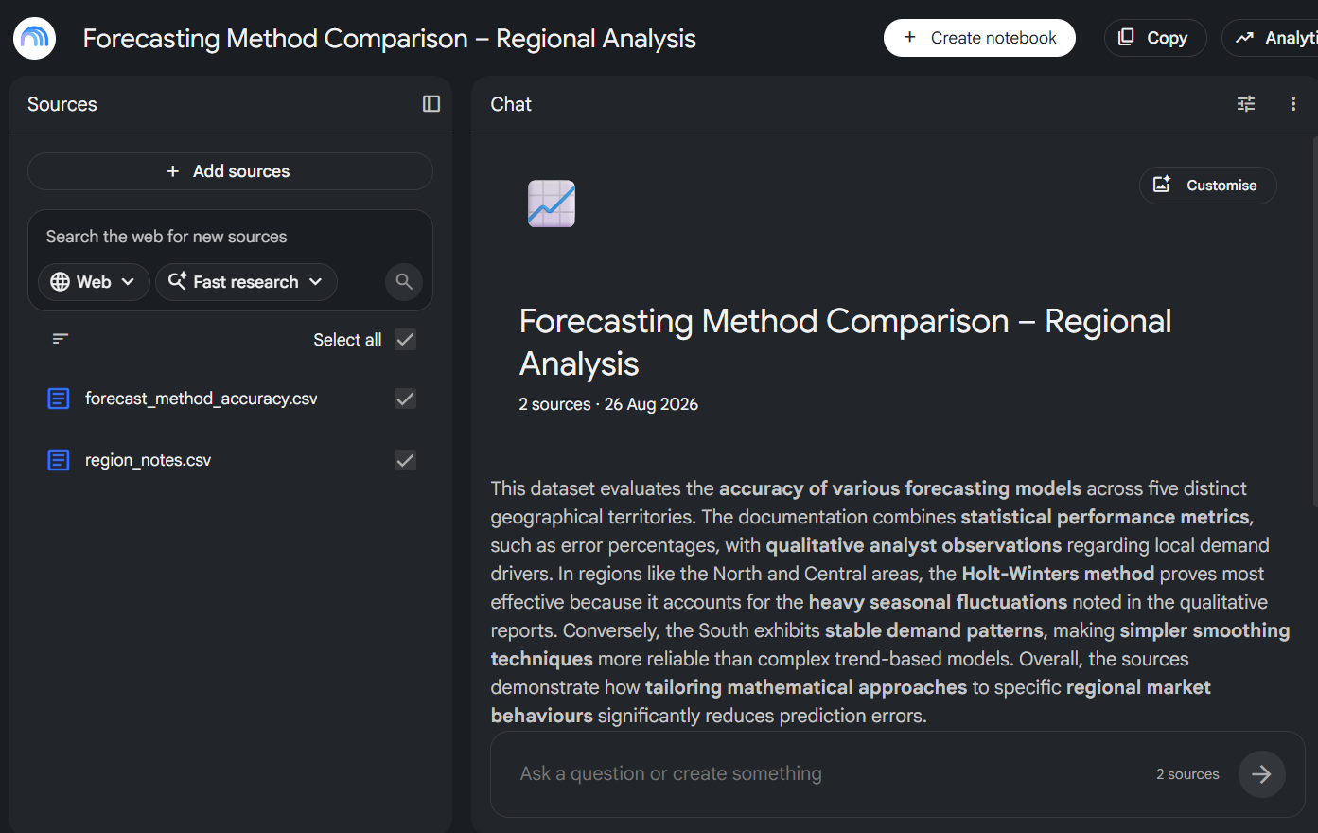

Task2 :
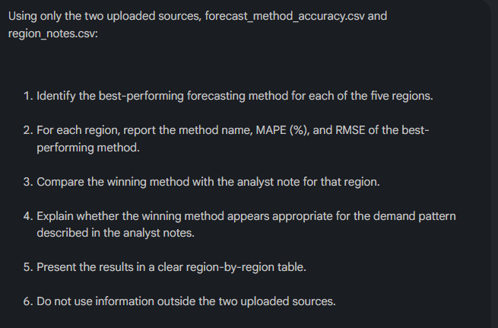
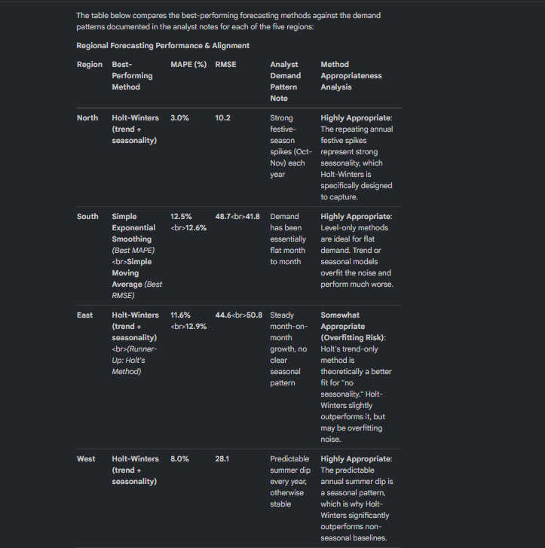
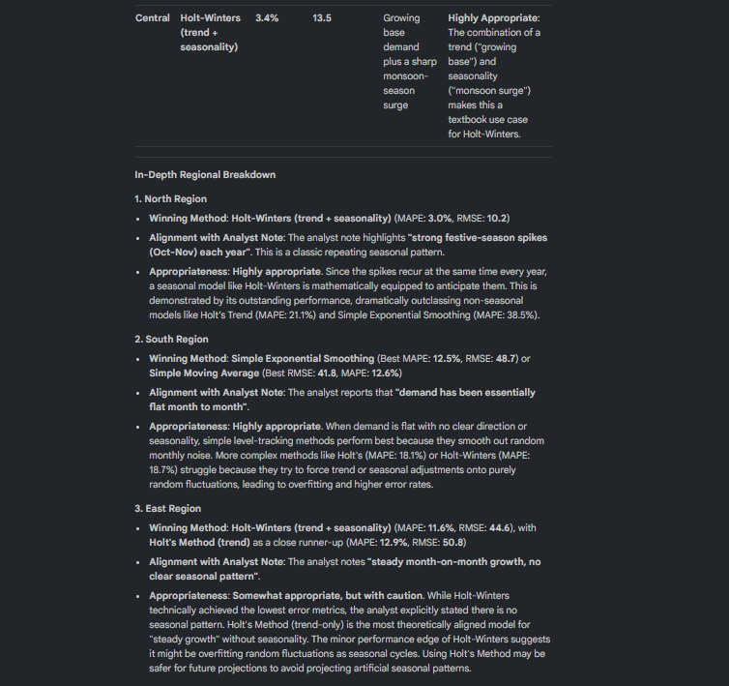
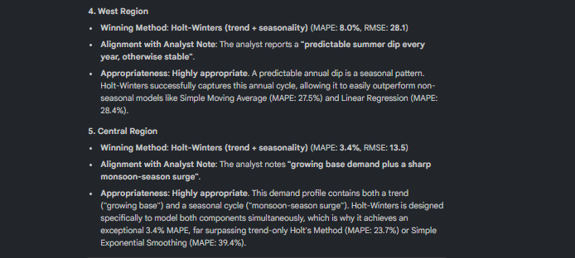
Task3 :
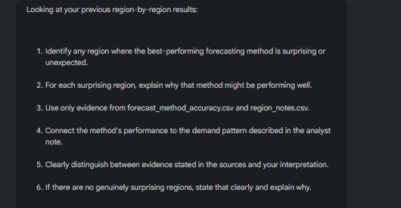
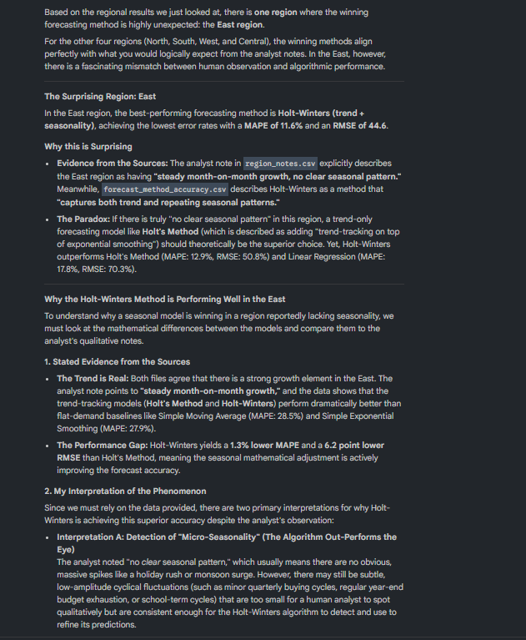
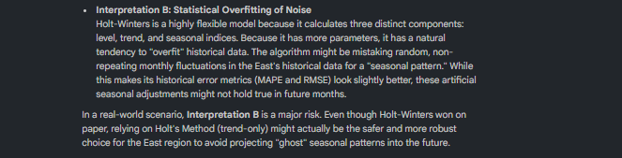

Task4 :
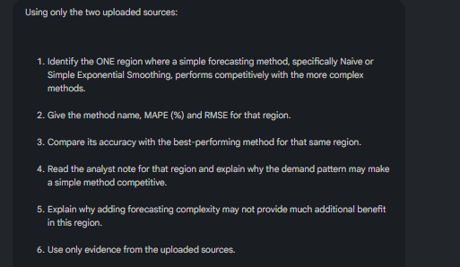
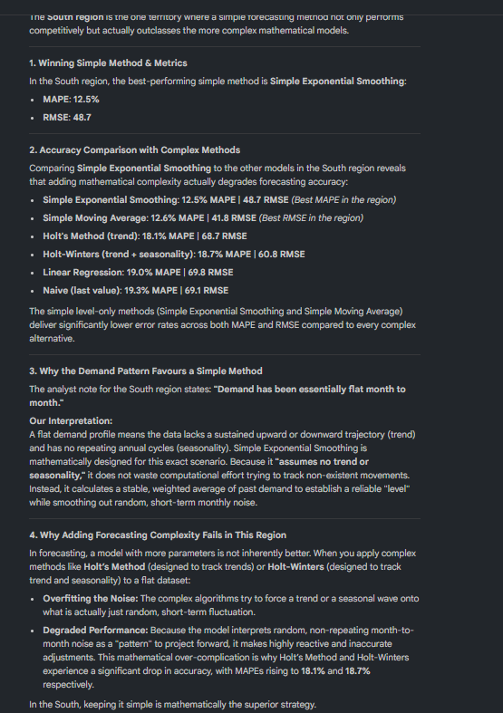

Task5:
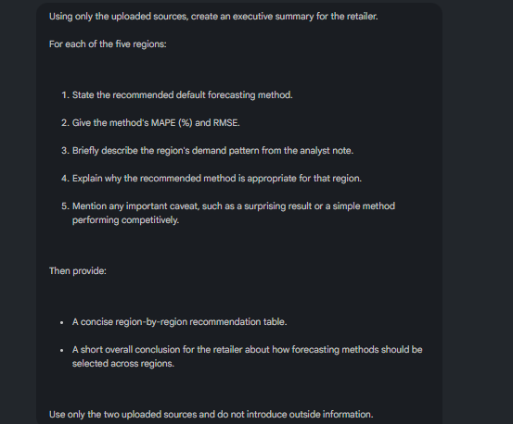

Executive Summary: Regional Demand Forecasting Optimisation
1. Strategic Context and Objectives
In the current retail environment, tailoring forecasting methodologies to specific regional demand behaviours is a strategic necessity for the optimisation of inventory levels and operational efficiency. A "one-size-fits-all" approach to demand planning often results in significant working capital inefficiencies, leading to either excessive safety stock or damaging stockouts. By aligning our mathematical models with the distinct characteristics of each territory, we can protect regional service levels and improve overall margin health.
This summary evaluates five distinct retail regions—North, South, East, West, and Central—utilising historical error metrics, specifically Mean Absolute Percentage Error (MAPE) and Root Mean Square Error (RMSE), to identify the most accurate forecasting models. The following analysis demonstrates that a nuanced, non-uniform approach is required to transform our supply chain into a truly demand-driven asset.
2. Regional Performance Analysis and Recommendations
2.1 North Region: Managing Seasonal Volatility
The North region is defined by extreme volatility, where high-accuracy forecasting is the only defence against the costs of stockouts during peak periods. For a supply chain to remain responsive here, the model must be sensitive enough to anticipate rapid surges without losing track of the long-term trajectory.
- Recommended Method: Holt-Winters (Trend + Seasonality).
- Accuracy Metrics: MAPE of 3.0% and RMSE of 10.2.
- Demand Profile: Historical data identifies strong festive-season spikes in October and November each year.
- Strategic Justification: Holt-Winters is the only viable choice for the North, as it simultaneously captures the underlying growth trend and the repeating seasonal spikes identified in analyst reports.
- Critical Caveat: Simple models are entirely insufficient for this region. The Naive approach and Linear Regression fail to account for festive spikes, resulting in a tenfold increase in error (MAPEs of 31.0%–37.0%) compared to the recommended model.
While the North requires a model capable of handling extreme spikes, the South presents a case for the strategic advantage of simplicity in a stable environment.
2.2 South Region: Prioritising Simplicity in Stable Markets
In regions where demand remains constant, there is a clear strategic advantage to using parsimonious models. In a flat market, complex modelling often mistakes random noise for a signal, leading to erratic ordering and unnecessary fluctuations in inventory.
- Recommended Method: Simple Moving Average (SMA) or Simple Exponential Smoothing (SES).
- Accuracy Metrics: SMA recorded a MAPE of 12.6% (RMSE 41.8), while SES achieved a MAPE of 12.5% (RMSE 48.7).
- Demand Profile: Demand in the South is essentially flat month to month.
- Strategic Justification: Simple methods are highly effective here because they smooth out minor fluctuations without overreacting to the trivial noise inherent in a static market.
- Critical Caveat: Adding trend or seasonality components is counterproductive; the Holt-Winters method actually increases the error rate. In the South, complexity is the enemy of accuracy.
The transition from the South’s stability to the East’s trajectory requires a shift from smoothing noise to capturing a distinct, non-seasonal growth curve.
2.3 East Region: Balancing Growth and Overfitting Risks
Forecasting in growth-only environments requires a model that can track an upward trajectory while remaining disciplined enough to ignore non-existent seasonal patterns.
- Recommended Method: Holt’s Method (Trend).
- Accuracy Metrics: MAPE of 12.9% and RMSE of 50.8.
- Demand Profile: The region exhibits steady month-on-month growth with no clear evidence of seasonality.
- Strategic Justification: Holt’s Method safely captures the regional expansion without the risks associated with multi-component modeling.
- Critical Caveat: We must ignore the "numerical paradox" where Holt-Winters shows a slightly lower MAPE (11.6%). This 1.3% improvement is mathematically illusory; since analysts have confirmed no seasonal pattern exists, using Holt-Winters carries a high risk of overfitting the model to micro-seasonality, which would degrade future forecasting reliability.
While growth is the primary driver in the East, the West region necessitates a model capable of navigating recurring seasonal troughs within a stable base.
2.4 West Region: Capturing Cyclical Summer Dips
In the West, the primary objective is to anticipate predictable downturns. Failure to adjust inventory ahead of these dips leads to significant overstocking and margin erosion through forced markdowns.
- Recommended Method: Holt-Winters (Trend + Seasonality).
- Accuracy Metrics: MAPE of 8.0% and RMSE of 28.1.
- Demand Profile: The market is otherwise stable but experiences a predictable summer dip every year.
- Strategic Justification: Capturing this repeating seasonal "dip" is the primary driver for selecting Holt-Winters, ensuring that procurement is dialed back appropriately during the summer months.
- Critical Caveat: Models that fail to account for this dip, such as Holt’s Method or Simple Exponential Smoothing, result in unacceptably high MAPEs of approximately 29.5%–30.9%.
The predictable cycle of the West provides the foundation for addressing the Central region, which represents our most complex and aggressive demand environment.
2.5 Central Region: Addressing High-Growth and Extreme Seasonality
The Central region is the highest complexity zone, where base growth and environmental factors (monsoons) coincide. This environment requires the most robust modeling possible to ensure service levels are maintained during massive surges.
- Recommended Method: Holt-Winters (Trend + Seasonality).
- Accuracy Metrics: MAPE of 3.4% and RMSE of 13.5.
- Demand Profile: This region is defined by a growing base demand coupled with a sharp, aggressive monsoon-season surge.
- Strategic Justification: The dual-component nature of Holt-Winters is essential for managing both the underlying growth trend and the extreme seasonal surge. The low MAPE of 3.4% proves the model's ability to track these aggressive shifts accurately.
- Critical Caveat: Any method that ignores seasonality is a risk to the business; the Simple Moving Average, for instance, results in an unacceptable MAPE of nearly 39%.
3. Consolidated Regional Recommendation Summary
The following table provides a quick-reference guide for system configuration. Technical teams should prioritise these settings to align with historical performance.
Region | Demand Pattern | Recommended Method | MAPE (%) | RMSE
North | Seasonal Spikes (Festive) | Holt-Winters | 3.0% | 10.2
South | Flat / Stable (Month-on-Month) | Simple Moving Average (SMA) | 12.6% | 41.8
East | Steady Month-on-Month Growth | Holt’s Method (Trend) | 12.9% | 50.8
West | Recurring Summer Dip | Holt-Winters | 8.0% | 28.1
Central | Growth + Monsoon Surge | Holt-Winters | 3.4% | 13.5
4. Strategic Synthesis and Conclusion
The analysis of these five regions confirms a strategic mandate for our supply chain: forecasting excellence is predicated on a "one size does not fit all" philosophy. While complex methodologies like Holt-Winters are indispensable in the North, West, and Central regions—where trend and seasonality coexist—they are actively counterproductive in the South and East.
Adopting these region-specific models is not merely a mathematical exercise; it is a critical risk-mitigation strategy designed to protect service levels and optimise working capital. Technical teams are instructed to update the forecasting system parameters immediately based on the consolidated summary table to ensure our inventory posture reflects the physical reality of our markets.

Audio Overview :
https://notebook.google.com/notebook/4119618e-d73f-463b-9d77-62af78cd4025/artifact/e9742d13-59a9-4e42-8095-c319d3211a39?utm_source=nlm_web_share&utm_medium=google_oo&utm_campaign=art_share_1&utm_content=&utm_smc=nlm_web_share_google_oo_art_share_1_
Task6 :
NotebookLM Critique
NotebookLM added genuine value by combining the numerical forecasting results with the analyst notes for each region. Reading the accuracy spreadsheet alone would show which method has the lowest MAPE or RMSE, but it would not explain whether that result makes sense for the region's demand pattern. The synthesis was particularly useful when connecting forecasting performance with patterns such as seasonal spikes, stable demand, or other characteristics described by the analysts. It also helped identify cases where a simpler forecasting method remained competitive and provided a reason for why additional complexity might not provide enough benefit.
However, some parts of the response mainly restated information already present in the spreadsheet. Reporting the best method, MAPE, and RMSE for each region did not add much new insight because those values can be directly read from the source data. The main contribution of NotebookLM was therefore not calculating the numbers, but combining the two sources and turning them into understandable, region-specific recommendations.

